Global forest and agricultural fires have reduced remarkably but not where it matters the most

Hrishikesh Chandra Gautam & Purushottam Gupta
____________________________________________________________________________

This analysis represents our first-cut analysis. Have critical comments or suggestions? Please email us at guptap@uchicago.edu / hcgautam@uchicago.edu

If someone asks you about forest or agricultural fires and their spread across the world, pictures and news of forest fires across Canada, Los Angeles, Bolivia, Amazonia, Northern Thailand and Indonesia flashes in mind. It may even be hard for you to believe that global burnt area has declined significantly in recent years but it's true. Yes, the global burnt area has reduced but not really where it matters.

Global burnt area has declined over the last two decades, but South Asia and North America didn’t follow the same trend, i.e. burnt area in India has risen by over 40% since the early 2000s, even as the global total has fallen, according to an analysis of satellite data.

An analysis of annual satellite-derived burnt area data has found that while the total area burnt by wildfires worldwide has declined since 2002, the trend is reversed in South Asia and North America — regions where forest cover overlaps with dense human population, raising concerns for public health and air quality.

The analysis, based on GLOBFIRE, a satellite dataset that has tracked burnt area across 183 countries since 2002, found that global burnt area fell from approximately 184 million hectares in 2002 to approximately 162 million hectares in 2024, a decline of around 12 percent. The finding is consistent with an earlier study published in Science in 2017, which had reported a 24% decline in global burnt area between 1998 and 2015, attributed to the mechanisation of agriculture reducing the traditional practice of burning land in the savannas of Africa and South America.

The data show, however, that this decline is not uniform. Only two regions recorded an increase in burnt area over the period under review: the United States and Canada, where burnt area rose by 20 percent, and South Asia, where it rose by 39 percent. Both regions combine substantial forest cover with high population density, a combination that has significant implications for particulate air pollution exposure (Figure 1).

In India, burnt area increased by an estimated 41% between the 2002-06 and 2020-24 periods, concentrated in forest tracts along the Himalayan foothills and in central India. The finding is significant given the country's existing air pollution burden. South Asia accounts for an estimated 45 percent of life-years lost to air pollution globally. According to the Air Quality Life Index (AQLI), an estimated 46 percent of India's population continues to be exposed to annual PM_{2.5} levels exceeding the national standard of 40 µg/m³, despite improvement in recent years, AQLI's most recent report has noted separately.

Figure 1. Regional Time series of burnt area across the globe

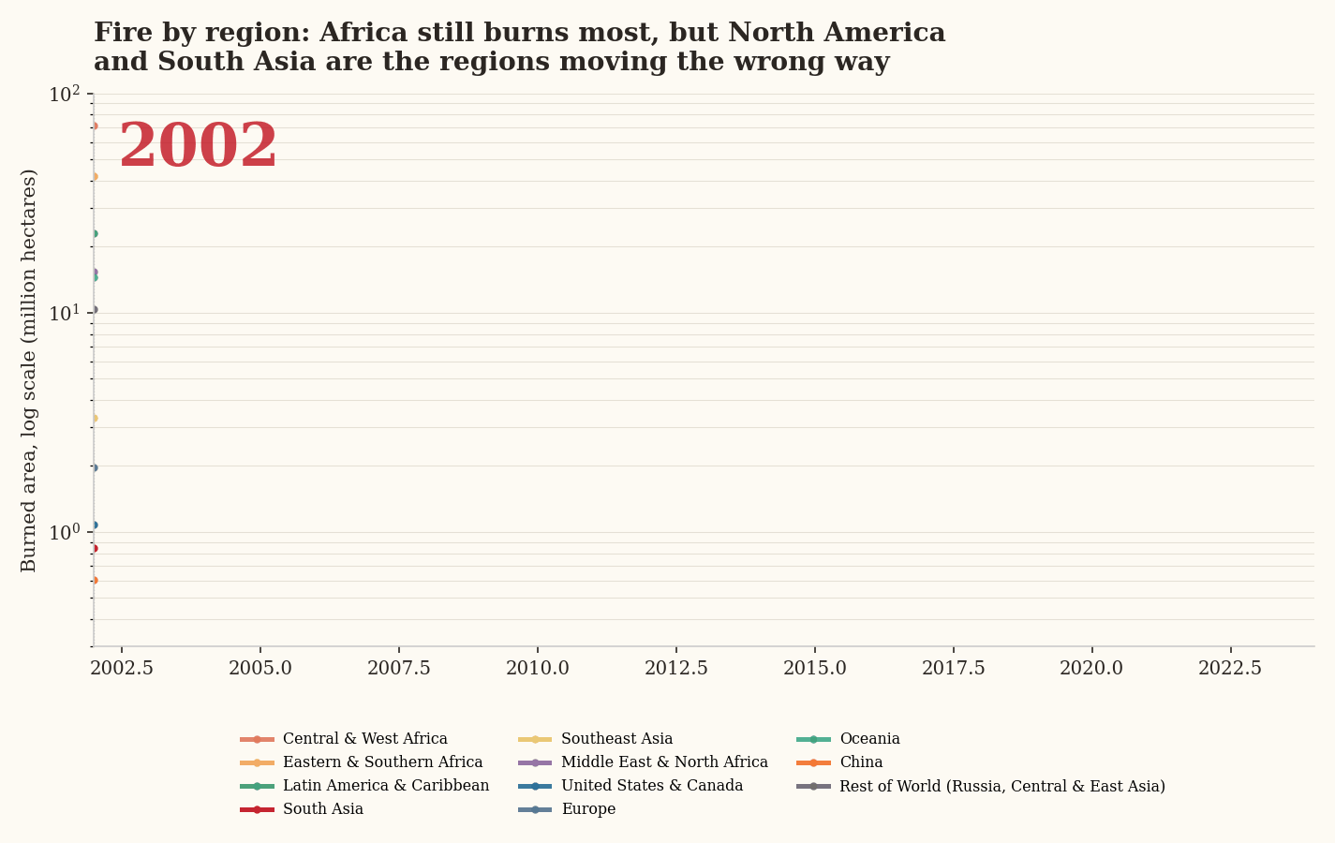

Africa continues to account for the major fraction of global burnt area, the analysis found, with Central and West Africa, and Eastern and Southern Africa together responsible for roughly 44.3 and 21.6 % of the global total in 2024. The region predominantly accounts for many countries with largest burnt areas across the world (Figure 2). This burning, however, is predominantly agricultural and savanna fire rather than forest fire, and its extent has been declining as farming practices in the region modernise.

Canada recorded the sharpest rise among individual countries, with average annual burnt area roughly doubling since the early 2000s. The 2023 fire season alone accounted for an estimated 1.58 million hectares in the GLOBFIRE data — more than six times the country's 2002 total — with smoke from the fires detected as far south as the northeastern United States.

Figure 2. Top countries by annual burnt area over the years

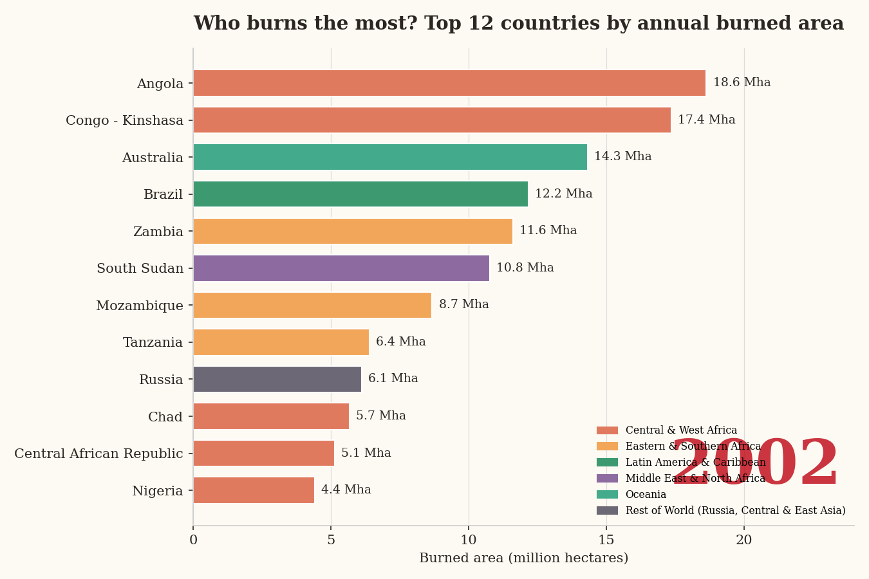

The analysis also flagged two significant outliers. Indonesia's burnt area fell by approximately 82% over the period, attributed to stricter peatland-fire management following haze crises in 2015 and 2019 that had affected neighbouring Singapore and Malaysia. Syria, on the other hand, recorded the sharpest percentage increase in the dataset 471% though officials cited in the analysis attributed this largely to deliberate burning of agricultural land amid the country's ongoing conflict, rather than to weather conditions. Burnt area in Syria rose from 8,200 hectares in 2018 to 5,44,000 hectares in 2019, with reports at the time attributing much of the burning to attacks on wheat and barley fields in the country's north-east .

A 2023 study published in Nature, led by researchers at Stanford University, found that wildfire smoke had slowed or reversed air quality improvements in 35 states in the U.S. since 2016, offsetting an estimated 25% of the gains made since 2000 in the affected States. Unlike pollution from industry or vehicles, the study noted, emissions from wildfires fall outside existing regulatory frameworks, posing a distinct challenge for air quality management.

Data for the 2024-25 fire season, tracked separately by the Copernicus Atmosphere Monitoring Service, showed that while global burnt area remained below the two-decade average, fire-related carbon emissions were around 9% above average — the sixth-highest on record — reflecting a concentration of fire activity in carbon-dense forest regions in Canada, Bolivia and Brazil.

The global wildfire and agricultural burning data tells us a story with two sides. First, that overall burnt area has reduced in the last two decades especially in Latin America and Africa. Africa being the major hotspots for burnt area, reduction in burnt area in this region has also contributed to overall reduction in global burnt area. This reduction is mostly a result of improvement in agricultural patterns leading to reduced burning of agricultural land and savanna. Secondly, the regions where burnt area has increased over the period are South Asia, United States and Canada. South Asia has the most densely populated regions in the world with high load on life expectancy loss creating a major impact on global particulate pollution affecting overall health and mortality. In the case of the United States and Canada, the smoke from wildfires is undoing the effect of long term effort applied through policy measures and intervention strategies over the decades.

https://www.science.org/doi/10.1126/science.aal4108
https://aqli.epic.uchicago.edu/
https://aqli.epic.uchicago.edu/report/annual-update-2025
https://www.nature.com/articles/s41586-023-06522-6
https://www.nature.com/articles/s41597-019-0312-2
https://essd.copernicus.org/articles/17/5377/2025/

